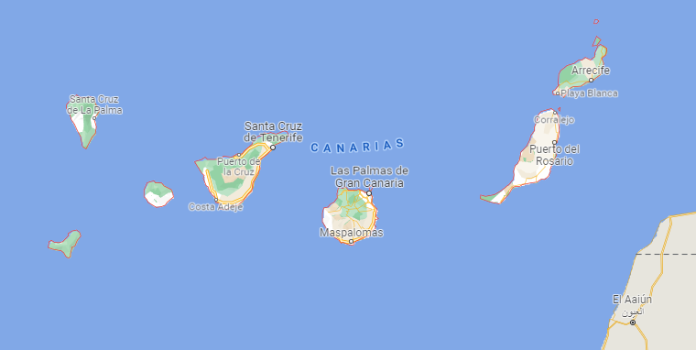 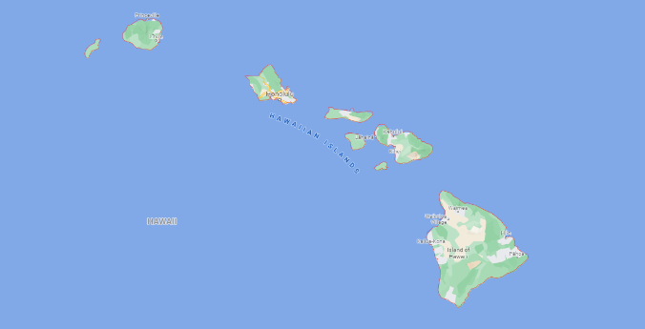

**Insular functional trait diversity**

This project is a follow up of the analysis we performed on the third week (Tuesday afternoon). We analyzed the plant trait diversity of Hawaiian forest that belong to two contrasting environments, wet and dry. We used four traits that relate to plant responses to water availability: specific leaf area (SLA), maximum plant height (H), stem specific density (WD), leaf nitrogen content (N).

With this project you will continue working with the Hawaiian archipelago data, that is, the trait and community data. You will compare the Hawaiian data (preferably choosing one or two islands, e.g., O'ahu Island and Hawai'i) to dry and wet areas of an island in the Canary Islands archipelago, Tenerife.

Starting research question: how does the plant functional trait diversity vary in two different isolated systems, Hawai’i and Tenerife and is there a variation of the functional trait diversity across the different water availability environments of both archipelago islands, i.e., wet and dry ecosystems?

1. Use the Chao et al 2019 approach to test for differences between functional richness of dry and wet areas for both Hawai’i and Tenerife, and/or O'ahu and Tenerife.
2. Do you find an archipelago having higher values of functional richness for any of the two environments you are studying?
3. Visualize the trait-by-trait differences across archipelagos, do you find traits having similar distributions across island from different archipelagos?
4. Visualize the functional trait space of wet and dry areas for Hawai’i and Tenerife, and/or O'ahu and Tenerife. Do you find species having similar distribution across the trait space?
5. Based on the trait space visualization, which plant strategies can you observe? Are the plant strategies evenly distributed across wet and dry areas? Is there a dominance of a plant strategy that relates to the water availability of the environment?

Research about the climatic, biogeographical and geological conditions of both archipelagos, Hawaii and Canary Islands. Do these archipelagos have contrasting environments? Do they have similar geological histories (ages)? How the environmental and geological conditions of both archipelagos can be affecting the functional diversity of the islands you are comparing.